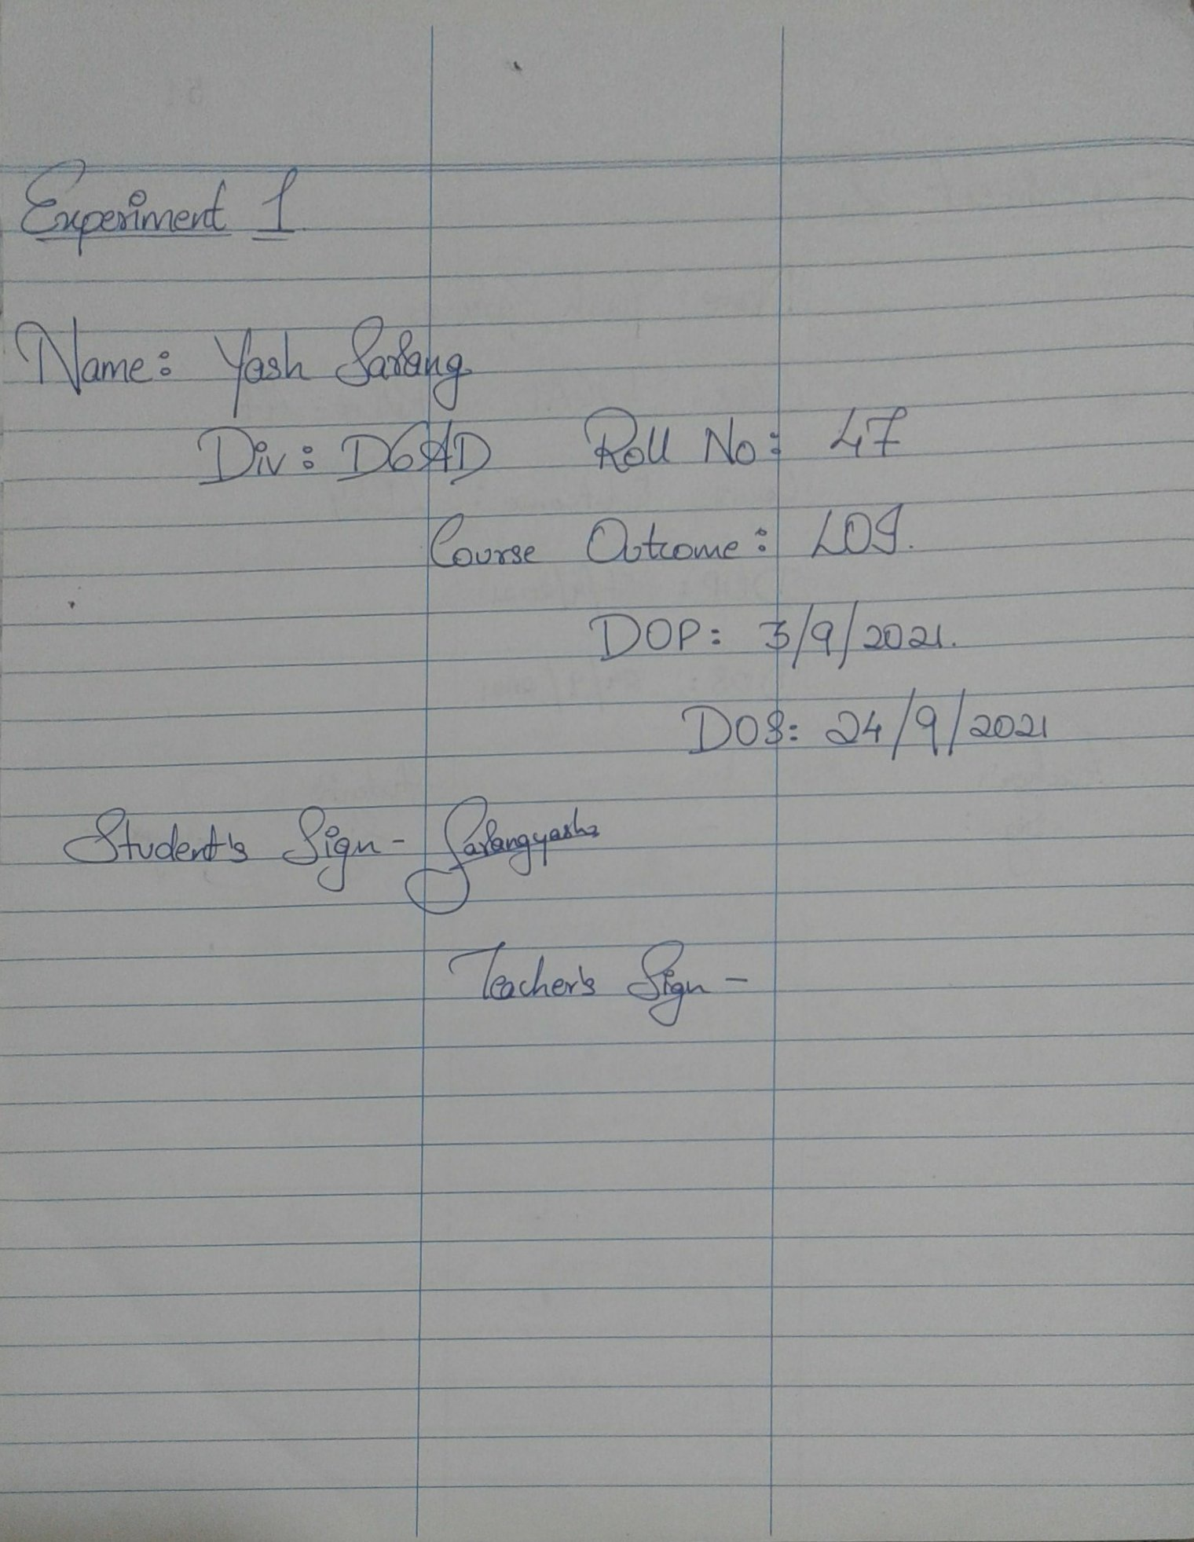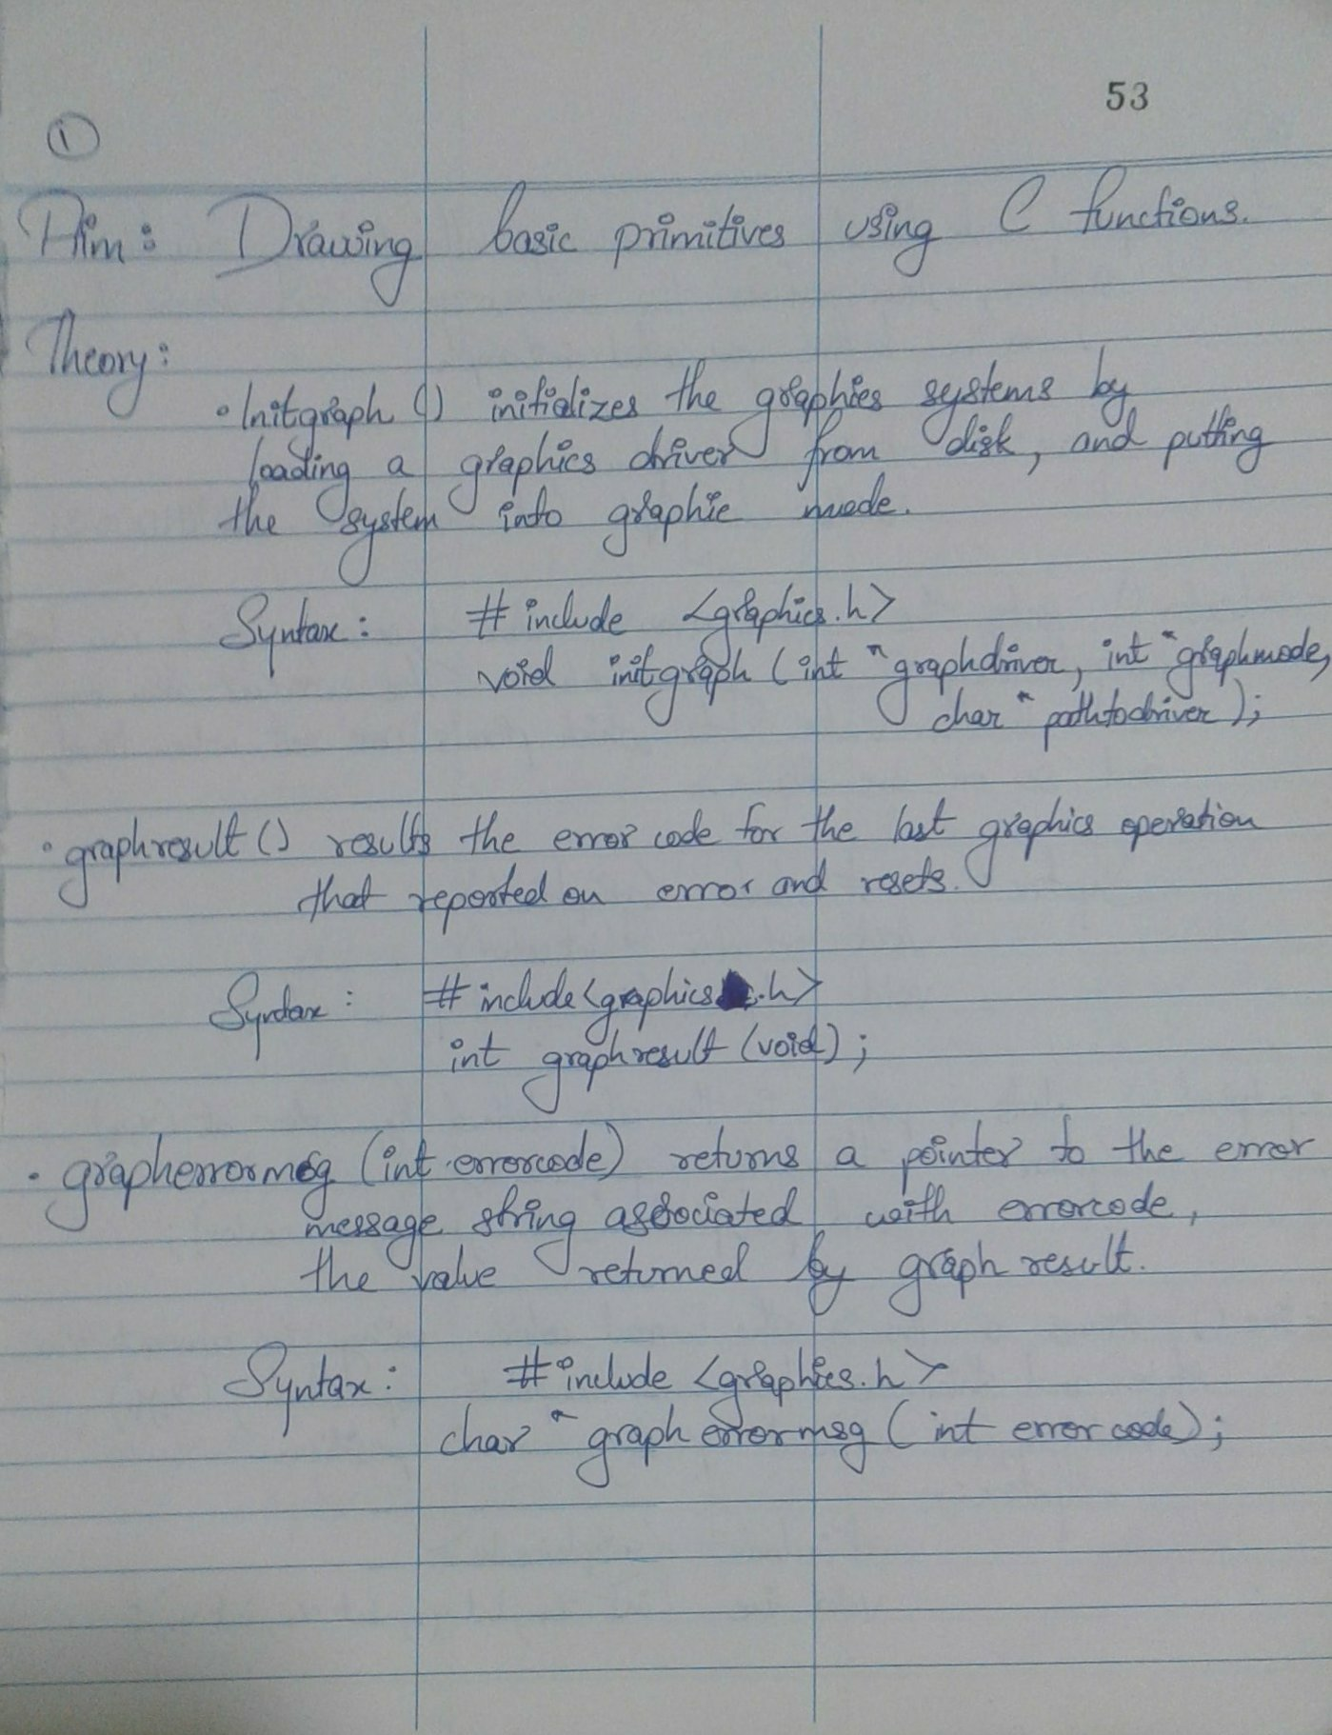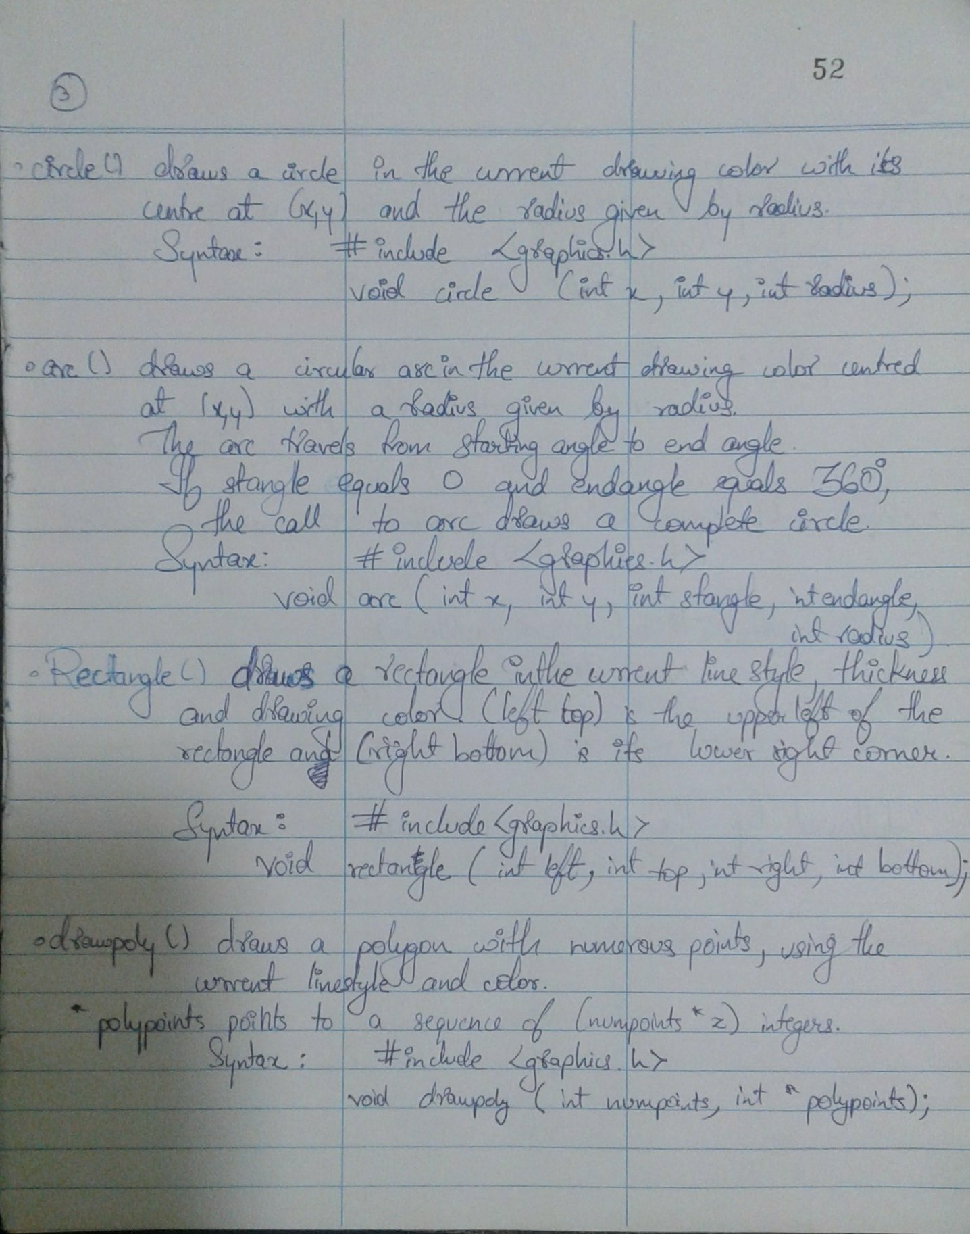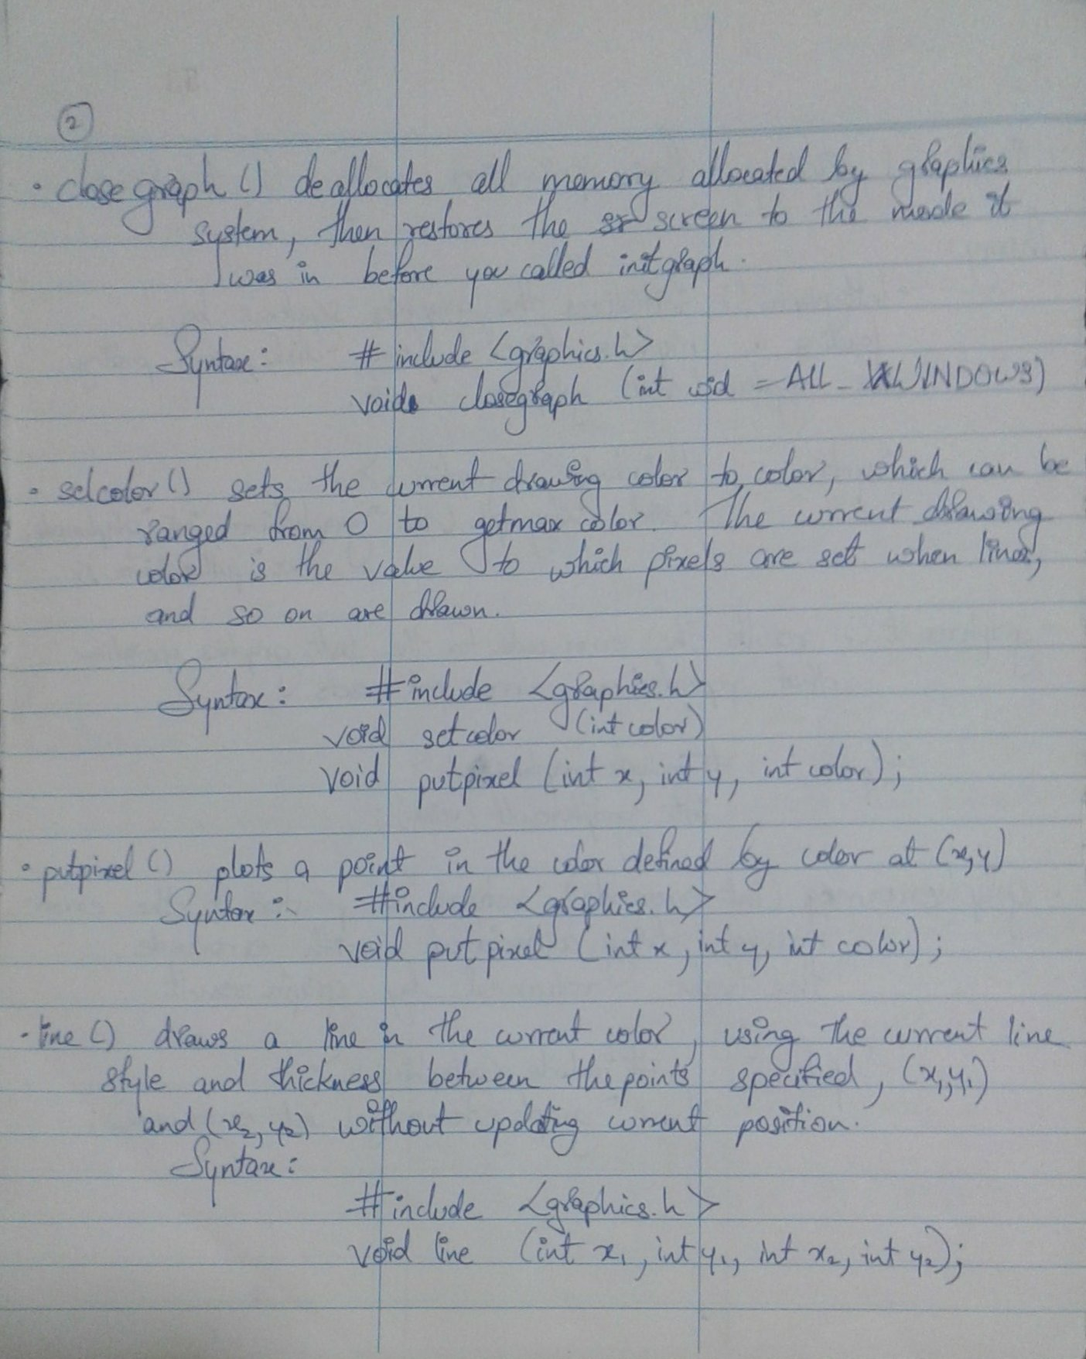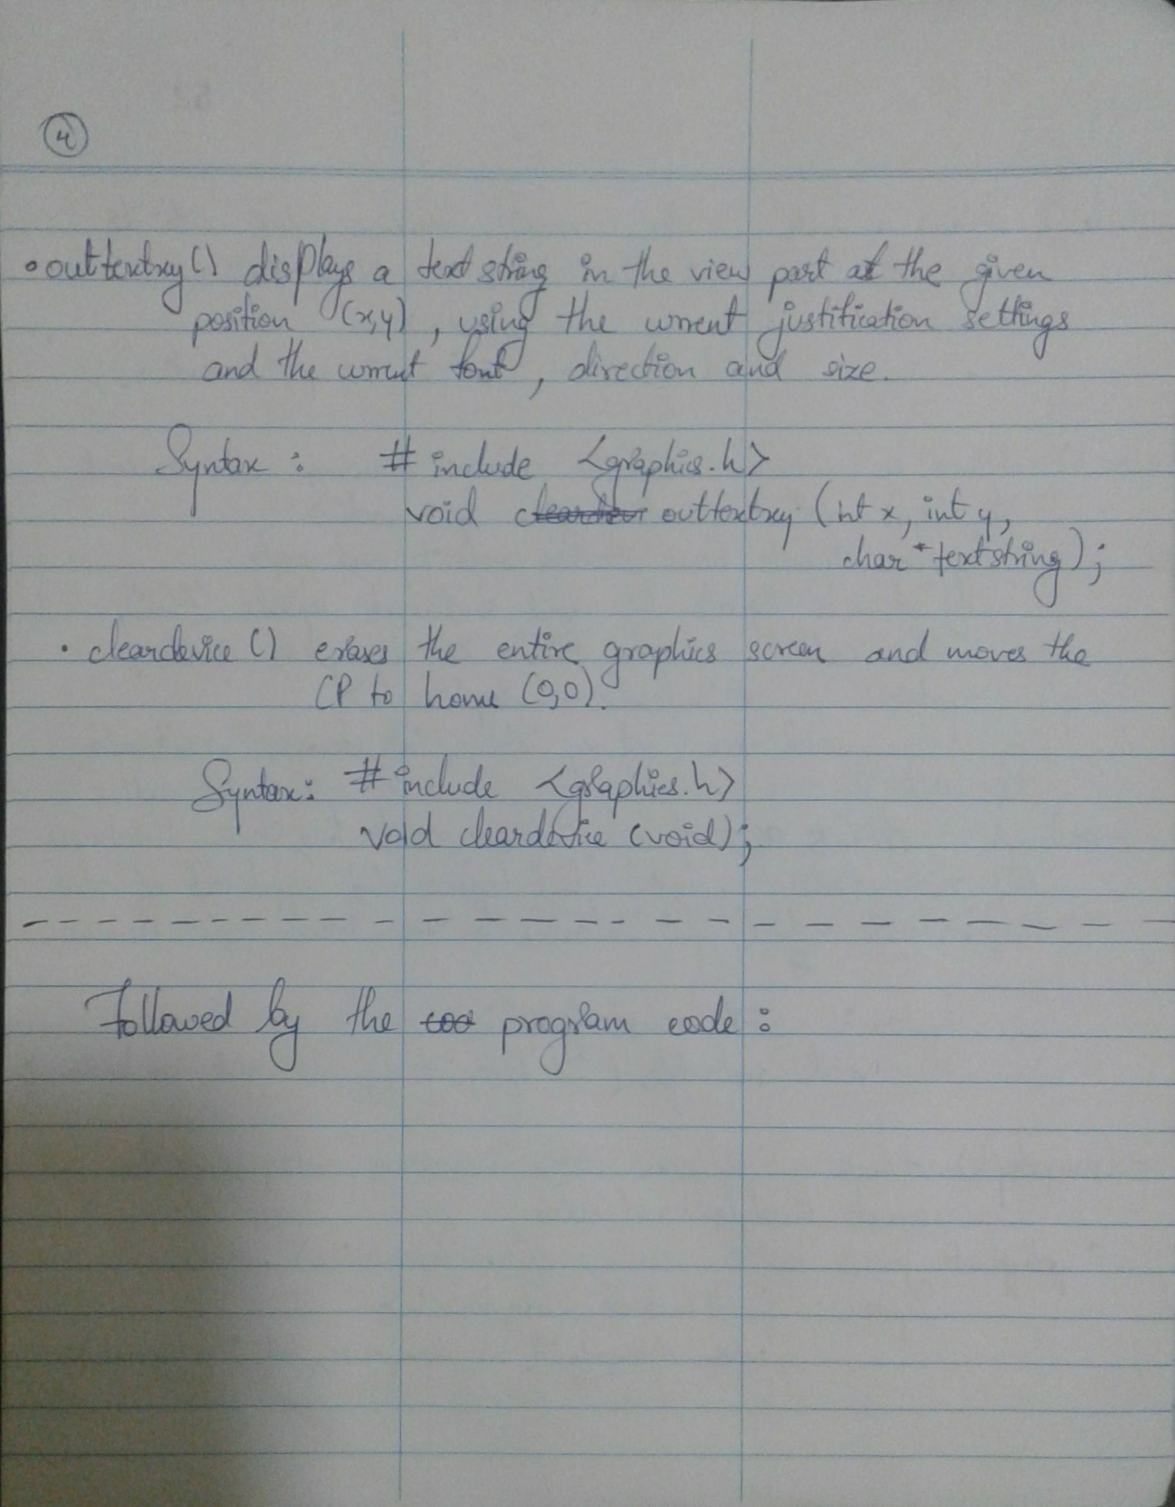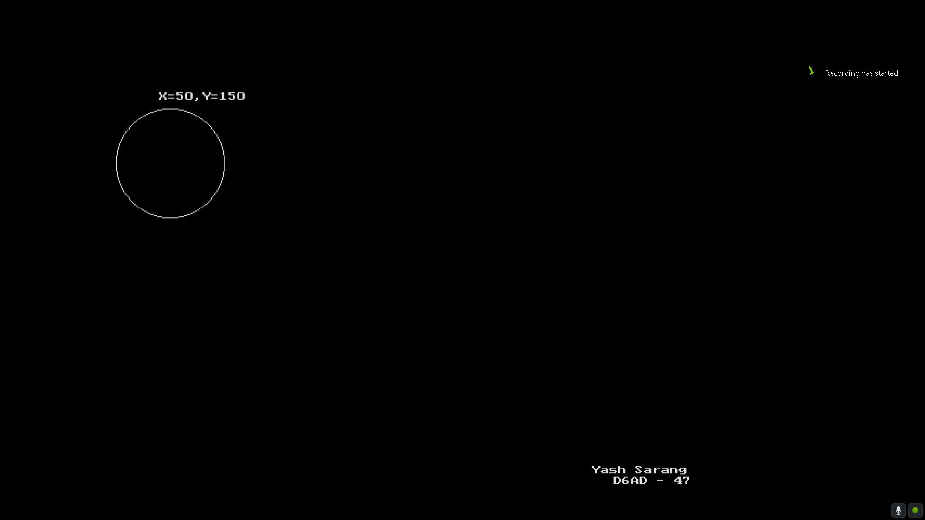

_________________________________________________________________________________________________

**CODE:**

#include <stdio.h>

#include <graphics.h>

#include <stdlib.h>

#include <conio.h>

int main()

{

int gdriver=DETECT, gmode, errorcode;

int xmax, ymax;

int x=50, y=150;

char buffer[20];

initgraph(&gdriver,&gmode,"C:\\TURBOC3\\BGI");

errorcode=graphresult();

if(errorcode!=0)

{

printf("Graphics error: %s\n",grapherrormsg(errorcode));

printf("press any key to halt:");

getch();

exit(1);

}

setcolor(getmaxcolor());

xmax=getmaxx();

ymax=getmaxy();

line(xmax/2,0,xmax/2,ymax);

line(0,ymax/2,xmax,ymax/2);

outtextxy(xmax-150,ymax-50,"Yash Sarang");

outtextxy(xmax-95,ymax-40,"D6AD - 47");

setcolor(RED);

circle(100,100,30);

outtextxy(100,150,"CIRCLE X=100 Y=100");

setcolor(GREEN);

rectangle(350,100,400,200);

outtextxy(350,205,"RECTANGLE");

setcolor(BLUE);

ellipse(200,300,0,360,100,50);

outtextxy(150,360,"ELLIPSE");

setcolor(getmaxcolor());

rectangle(400,300,500,400);

outtextxy(400,ymax-70,"SQUARE");

getch();

cleardevice();

for(x=50;x<=400;x++)

{

circle(x,y,50);

sprintf(buffer,"X=%d,Y=%d",x,y);

delay(5);

if(x==50)

{

outtextxy(40,85,buffer);

outtextxy(xmax-200,ymax-50,"Yash Sarang");

outtextxy(xmax-180,ymax-40,"D6AD - 47");

getch();

}

if(x==400)

{

outtextxy(350,85,buffer);

outtextxy(xmax-200,ymax-50,"Yash Sarang");

outtextxy(xmax-180,ymax-40,"D6AD - 47");

getch();

}

cleardevice();

}

getch();

closegraph();

return 0;

}

_________________________________________________________________________________________________

**OUTPUT:**

